BOXIM (box simulator) Training at SMC

1) Introduction – endoscope system, how to handle the endoscope
2) Making friends with the endoscope
3) Torque rotation
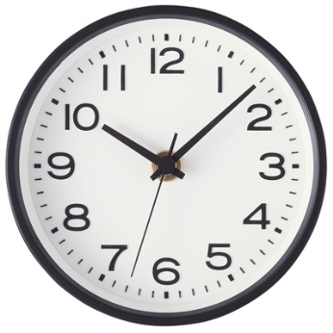
4) Polyp: Cardia (20cm, 5 o’clock) → Lower body GC (Boots up & 30cm, 12 o’clock) → Polyp (Knob up & 40cm) → Lower body GC (Knob down & 30cm, 12 o’clock) → Cardia (Boots down & 20cm, 5 o’clock)
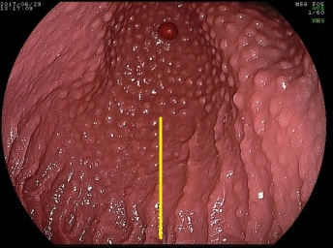
5) Short route: Knob down 1 cm at cardia → introduce the endoscope close to the lesser curvature Lower body GC (Boots up & 30cm, 12 o’clock)
6) Angle: Maximum up & push 10 cm (Angle is located at 40 cm.)
7) Cardia (retroflection): Boots down (= counter-clockwise rotation) → back 10cm to cardia (30cm) → push 10cm to angle (40cm)
8) Lower body: Boots up to angle horizontal → release the knob and back 10cm lower body (30cm, 12 o’clock)
9) How to use the body motion
10) Rotate: rotate the scope near cardia (33cm)
11) Fundus: Knob up and counter-clockwise twist the scope to see the fundus
.